SHUTDOWN PROCEDURE – EROSION RIG

1. Make sure **V105**, **V106** & **V107** are open

2. Change the LabView values to their default

(equal to Step 5 of the *Start-up* *procedure*):

* Stop the air flow into the system setting **FIC104 setpt**, **FIC105 setpt** & **FIC106 setpt** to zero
* De-activate controllers
* Close valves **CV101**, **CV102** & **CV103**

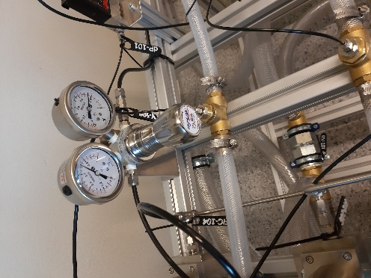

off

3. Turn off pressure regulator **V108**

*(clockwise – off | counter-clockwise – on )*

4. Close valves **V102, V103 & V104** *(any order)*

5. Close **V101** *(behind the pump)*

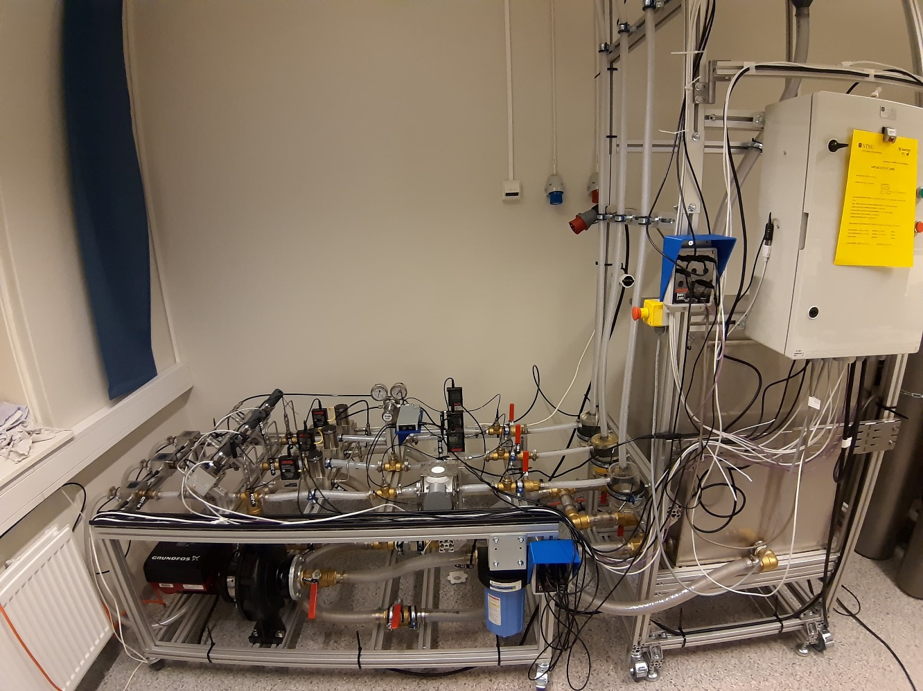

**V102, V103, V104**

**V108**

**V101**

**V105**

**V107**

**V106**

Page 1/2

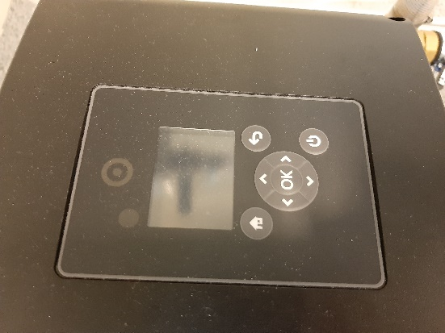

6. Turn off the pump

7. Stop the LabVIEW program by pressing the button.

Stop the logging first in case it is running

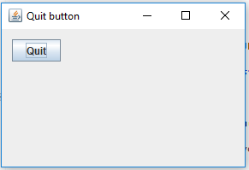

8. Turn off the cabinet *(red button)*

9. Disconnect 220 AC, 3-phase cable and the USB cables

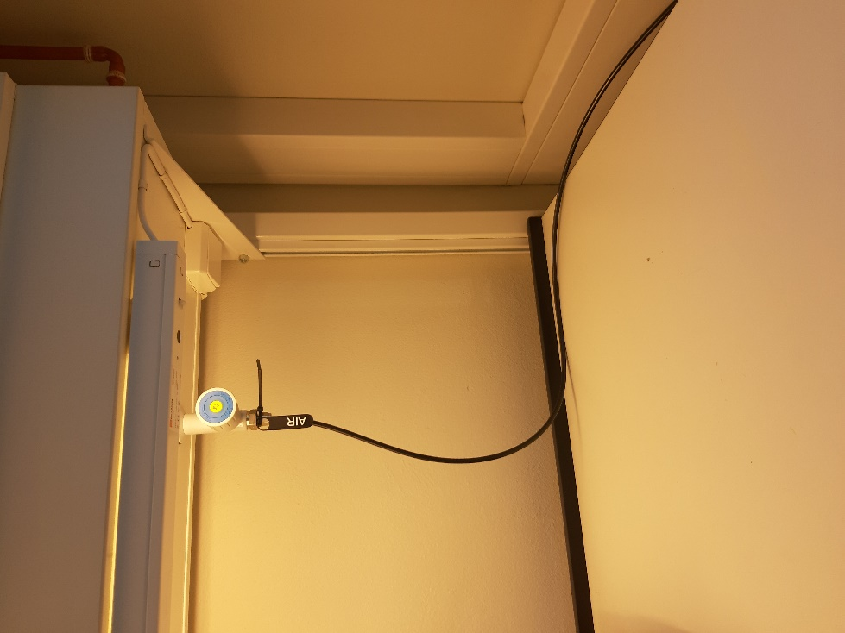

off

10. Turn off the air valve **AIR**

*(the valve near the computer, behind you)*

11. Close **V105**, **V106** & **V107**



**CABINET**

**PUMP**

**V105**

**V106**

**V107**

Page 2/2 *END*